**INVENTORY AND POS SYSTEM - USER DOCUMENTATION**

**Introduction**

The Inventory and POS System is designed to help retail businesses efficiently manage their inventory and sales processes. This document provides a comprehensive guide on how to use the system, covering everything from setting up your products to processing sales and generating reports.

**Getting Started**

**System Requirements**

* **Operating System:** Windows 10 or later, macOS 10.15 or later, or Linux.
* **Browser:** Google Chrome, Mozilla Firefox, Safari, or Microsoft Edge (latest versions).
* **Internet Connection:** Required for cloud-based data synchronization.

**Installation**

1. **Download the Installer:**
   * Download the setup file from the website or the installation media provided.
2. **Run the Installer:**
   * Double-click the downloaded file and follow the on-screen instructions.
3. **Complete the Installation:**
   * Choose the installation directory and complete the setup process.

**Login**

1. **Open the Application:**
   * Launch the application by double-clicking the desktop icon or selecting it from the Start menu.
2. **Enter Credentials:**
   * Input your username and password that you used during registration.
3. Register:

Click the “Register” button to register in case you don’t have username and password

1. **Login:**
   * Click the "Login" button to access the dashboard.

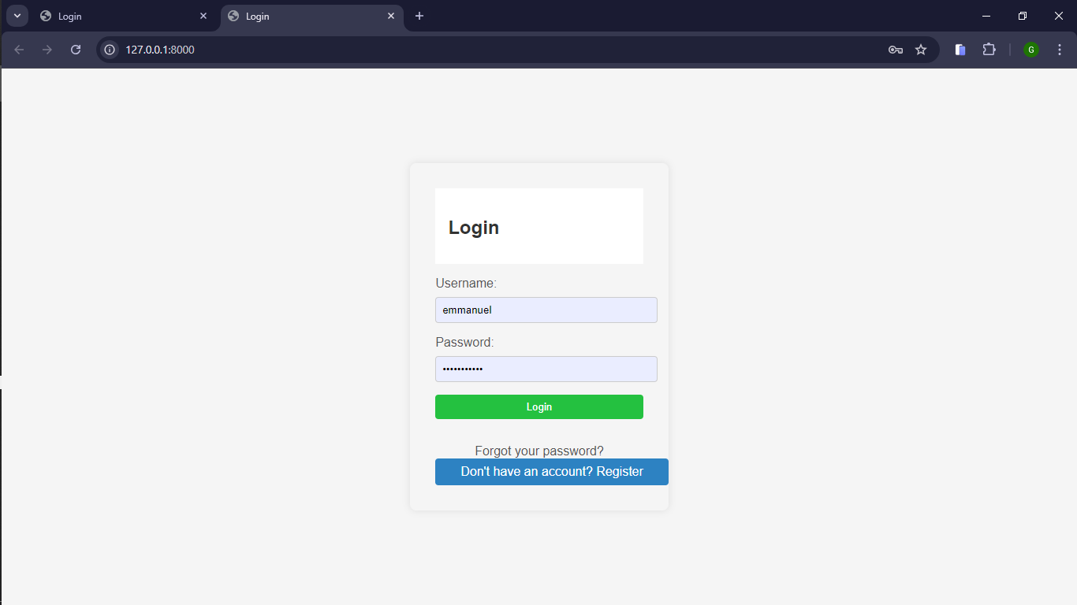

**Dashboard Overview**

The dashboard provides a snapshot of your business operations, including recent sales, low-stock alerts, and quick access to key features.

* **Navigation Menu:** Access different sections like Inventory, Sales, Products, Reports, and Settings.
* **Sales Summary:** View daily, weekly, and monthly sales performance.
* **Low-Stock Alerts:** See a list of products that are running low on stock.
* **Quick Actions:** Buttons for common tasks like adding a new product.

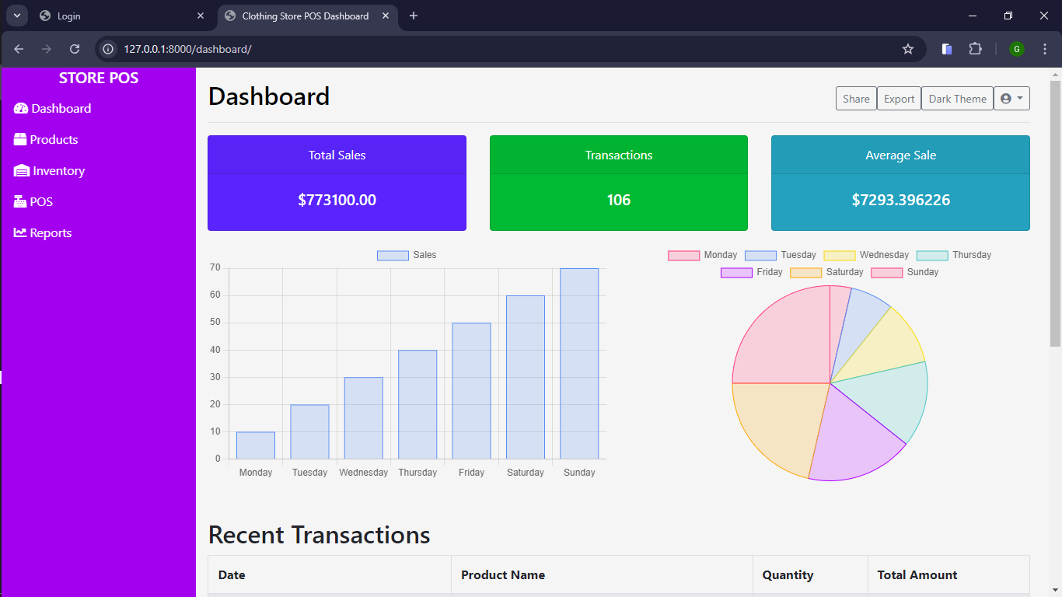

**Managing Inventory**

**Adding a New Product**

1. **Navigate to Product:**
   * Click on the "Product" tab in the navigation menu.
2. **Add Product:**
   * Click the "Add Product" button.
   * Fill in the product details such as Name, SKU, Price, and Stock Level.
   * Upload a product image (optional).
   * Click "Save" to add the product to your inventory.

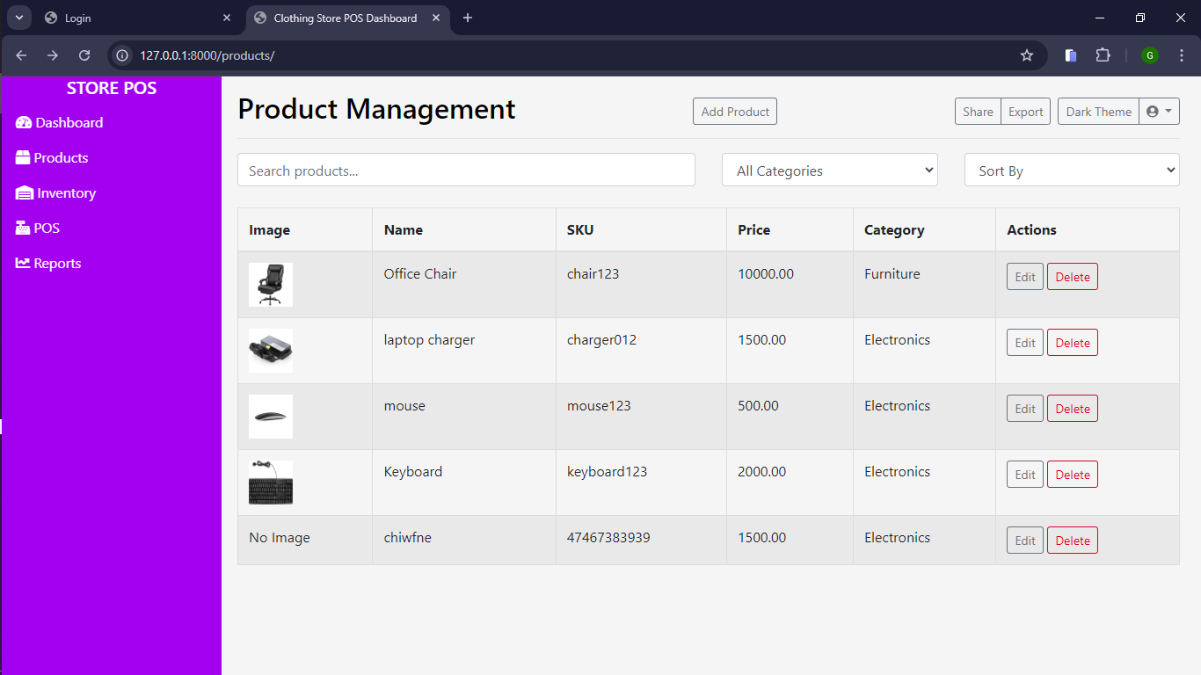

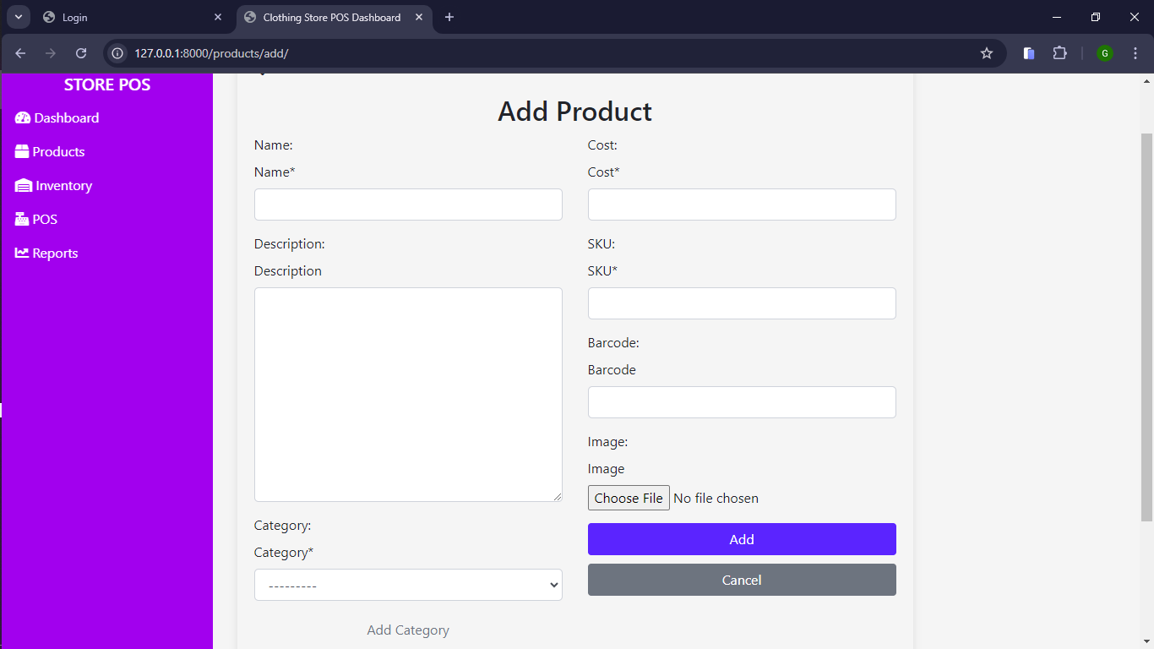

**Updating Product Information**

1. **Select Product:**
   * Find the product you want to update from the products list.
   * Click the "Edit" icon next to the product name.
2. **Edit Details:**
   * Update the necessary fields, such as price or stock levels.
   * Click "Save" to apply the changes.

**Deleting a Product**

1. **Select Product:**
   * Locate the product you wish to delete.
   * Click the "Delete" icon next to the product name.
2. **Confirm Deletion:**
   * Confirm the deletion when prompted. Note that this action cannot be undone.

**Viewing Stock Levels**

1. **Navigate to Inventory:**
   * Click on the "Inventory" tab.
2. **Stock Overview:**
   * View the current stock levels for all products.
   * Use the search bar to find specific products.
   * Filter by low stock or out-of-stock items.

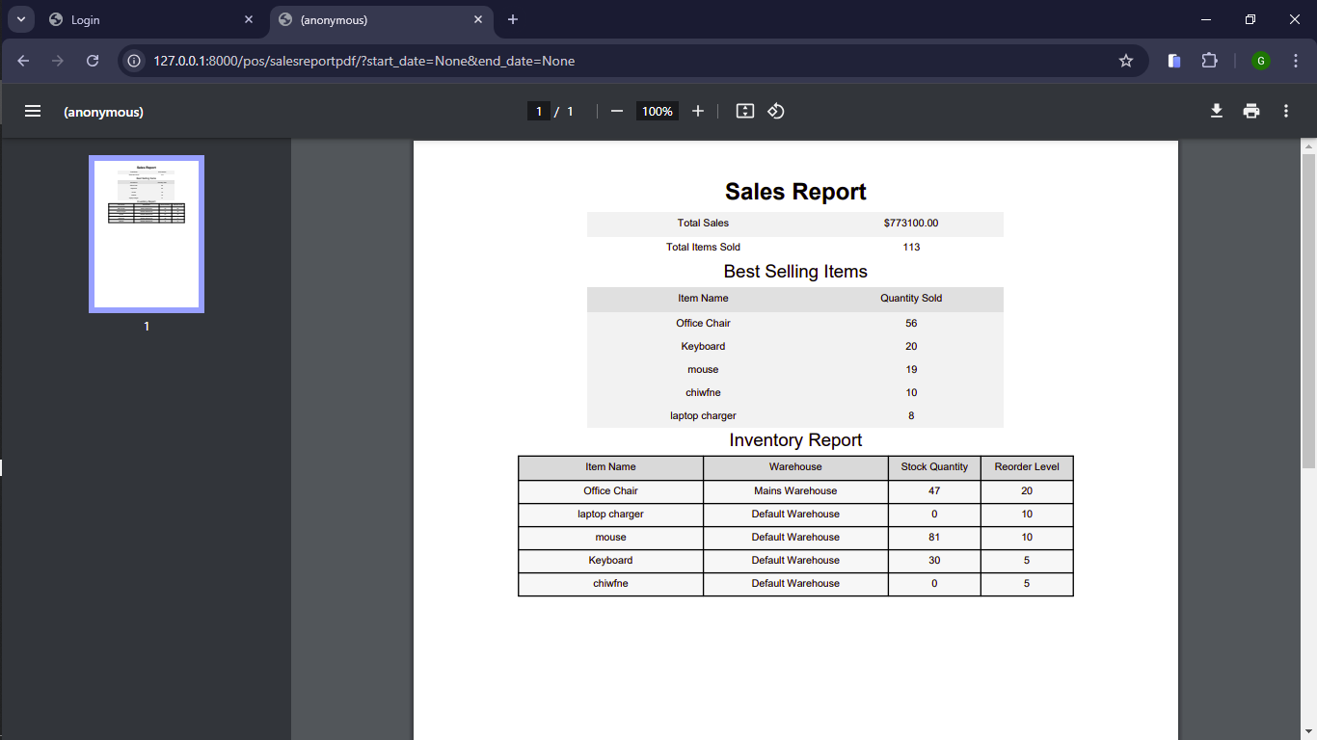

**Using the Point of Sale (POS) System**

**Creating a New Sale**

1. **Navigate to POS:**
   * Click on the "POS" tab in the navigation menu.
2. **Add Products to Sale:**
   * Search for the product by name or SKU and add it to the cart.
   * Adjust the quantity as needed.
3. **Complete the Sale:**
   * Click "Complete Sale" to proceed to payment.

**Processing Payments**

1. **Select Payment Method:**
   * Choose the payment method (e.g., Cash, Mobile Payment).
2. **Enter Payment Details:**
   * Input the amount received if paying by cash or enter card details for credit card payments.
3. **Confirm Payment:**
   * Click "Process Payment" to complete the transaction.

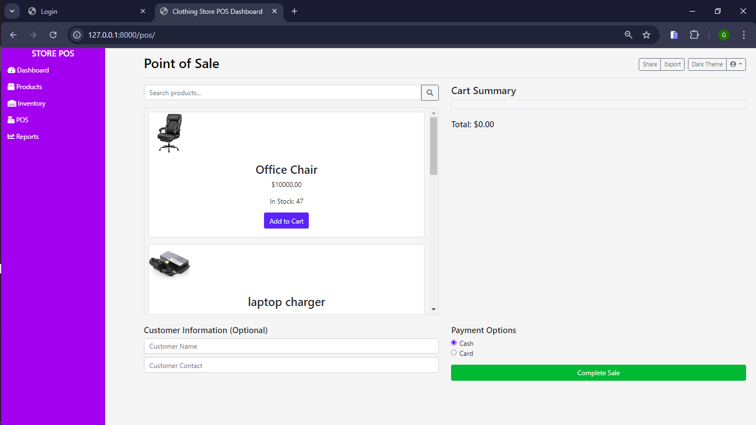

**Generating Receipts**

1. **Print Receipt:**
   * After the payment is processed, click "Print Receipt" to generate a paper receipt.
2. **Email Receipt (optional):**
   * Enter the customer’s email address and click "Send" to email the receipt.

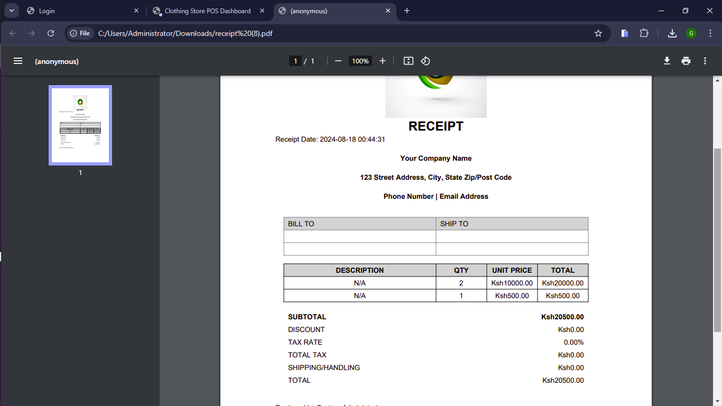

**Reports and Analytics**

**Sales Reports**

1. **Navigate to Reports:**
   * Click on the "Reports" tab.
2. **View Sales Reports:**
   * Select the "Sales Report" option.
   * Choose the desired date range and click "Generate Report."
   * View the report on-screen or export it as a PDF or Excel file.

**Inventory Reports**

1. **Navigate to Reports:**
   * Click on the "Reports" tab.
2. **View Inventory Reports:**
   * Select the "Inventory Report" option.
   * View stock levels, product movement, and other inventory metrics.

**Exporting Data**

1. **Navigate to Reports:**
   * Go to the "Reports" tab.
2. **Select Export Option:**
   * Choose the type of report you want to export.
   * Click the "Export" button and choose your preferred file format (PDF, Excel).

**Troubleshooting**

**Common Issues**

* **Cannot Login:** Ensure your username and password are correct. If you forgot your password, click "Forgot Password" to reset it.
* **Product Not Saving:** Check for any required fields that might be missing and ensure you have sufficient permissions to add products.
* **Payment Not Processing:** Verify that the payment gateway is correctly configured and that you have an active internet connection.

**Contact Support**

* **Email:** emmanuelokoth2002@gmail.com
* **Phone:** +254114567533
* **Hours:** Monday to Friday, 9 AM to 6 PM (EST)

**FAQs**

* **How do I reset my password?**
  + Go to the login screen, click "Forgot Password," and follow the instructions to reset your password.
* **Can I add multiple payment methods for a single transaction?**
  + Yes, the system allows you to split payments across different methods.
* **How do I back up my data?**
  + Navigate to Settings > Backup, and click "Create Backup" to save a copy of your data.